<https://www.silabs.com/products/development-tools/software/usb-to-uart-bridge-vcp-drivers>

For ESP32 use [ESP32 DEVKIT DOIT board](https://makeradvisor.com/tools/esp32-dev-board-wi-fi-bluetooth/)

* ESP32 has 30 OR 36 pins, 15 in each row.
* It also has wide variety of peripherals available, like: capacitive touch, ADCs, DACs, UART, SPI, I2C and much more.
* It comes with built-in hall effect sensor and built-in temperature sensor.

|  |  |
| --- | --- |
| https://i0.wp.com/randomnerdtutorials.com/wp-content/uploads/2018/08/Specifications.png?resize=813%2C589&ssl=1 | The [ESP32 has more GPIOs](https://randomnerdtutorials.com/esp32-pinout-reference-gpios/) with more functionalities compared to the ESP826.  With the ESP32 you can decide which pins are UART, I2C, or SPI – you just need to set that on the code. This is possible due to the ESP32 chip’s multiplexing feature that allows to assign multiple functions to the same pin.  If you don’t set them on the code, the pins will be used as default, the pin location can change depending on the manufacturer) |

|  |  |  |
| --- | --- | --- |
|  | **ESP8266** | **ESP32** |
| File Preference | http://arduino.esp8266.com/stable/package_esp8266com_index.json | <https://dl.espressif.com/dl/package_esp32_index.json> |
| Agregar Libreria | ESP8266 | ESP32 |
| Escoger Placa | NodeMCU 1.0 ESP-12E Module | DOIT ESP32 DEVKIT V1 |

**Version with 30 GPIOs**

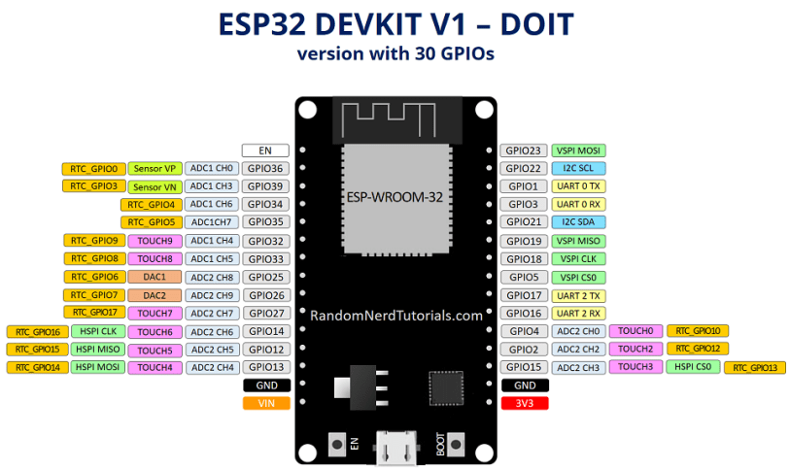

**Version with 36 GPIOs**

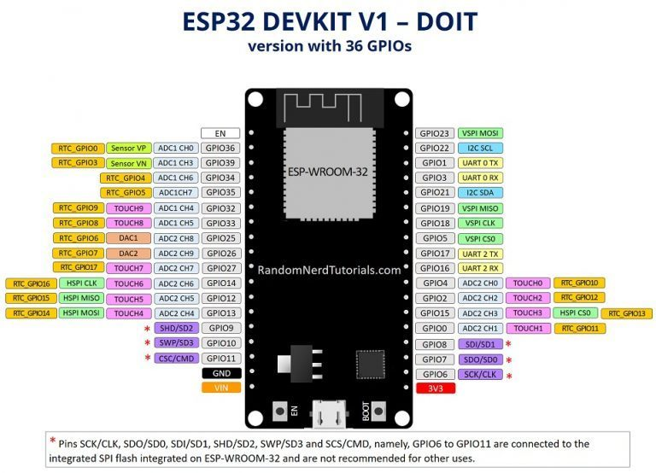

|  |  |
| --- | --- |
| // ledPin refers to ESP32 GPIO 23  const int ledPin = 23;  void setup() {  pinMode(ledPin, OUTPUT);  }  void loop() {  digitalWrite(ledPin, HIGH);  delay(1000);  digitalWrite(ledPin, LOW);  delay(1000);  } | https://i2.wp.com/randomnerdtutorials.com/wp-content/uploads/2018/08/blinkin_LED_schematic_bb.png?resize=645%2C532&ssl=1  330 Ohms |

|  |  |
| --- | --- |
| Plug your ESP32 development board to your computer and follow these next instructions:  Board: **DOIT ESP32 DEVKIT V1**  Select correct Port |  |

3) Press the upload button.

https://i2.wp.com/randomnerdtutorials.com/wp-content/uploads/2016/12/arduino-ide-upload-button.png?resize=34%2C29&ssl=1

**Note:** If you get the following error when trying to upload code, it means that your ESP32 is not in flashing/uploading mode.

**Failed to connect to ESP32: Timed out... Connecting...**

|  |  |
| --- | --- |
| Hold-down the “**BOOT**” button in your ESP32 board (before pressing Upload button) |  |
| Press the “**Upload**” button in the Arduino IDE to upload your sketch: | Arduino IDE uploading new sketch to ESP32 |
| After you see the  “**Connecting….**” message in your Arduino IDE, release the finger from the “**BOOT**” button |  |
| After that, you should see the “**Done uploading**” message |  |
| Your ESP8266 should have the new sketch running.  Press the “**ENABLE/RESET**” button to restart the ESP8266 and run the new uploaded sketch. |  |

Your ESP8266 should have the new sketch running and the LED is blinking every second in the GPIO 23.

**Note:**Learn how to fix the [“Failed to connect to ESP32: Timed out waiting for packet header” error](https://randomnerdtutorials.com/solved-failed-to-connect-to-esp32-timed-out-waiting-for-packet-header/) permanently when trying to upload new code to your ESP32 board once for all.

You may also like:

* [20+ ESP32 Projects and Tutorials](https://randomnerdtutorials.com/projects-esp32/)
* [ESP32 Pinout Reference: Which GPIO pins should you use?](https://randomnerdtutorials.com/esp32-pinout-reference-gpios/)
* [ESP32 vs ESP8266 – Pros and Cons](https://makeradvisor.com/esp32-vs-esp8266/)
* [Best ESP32 Development Boards](https://makeradvisor.com/esp32-development-boards-review-comparison/)